How do I apply for or permit?
To apply for a Building, Engineering, Fire or Planning Permits - start by clicking "Create an Application by Address"

Start by clicking on Create An Application by Address and do the following:
- Under the Enter Work Location header enter the street number in the
"Street No. From" field and leave the "Street No. To" field empty.
- Enter the street name in the Street Name dialogue box.
- Click “Search.”
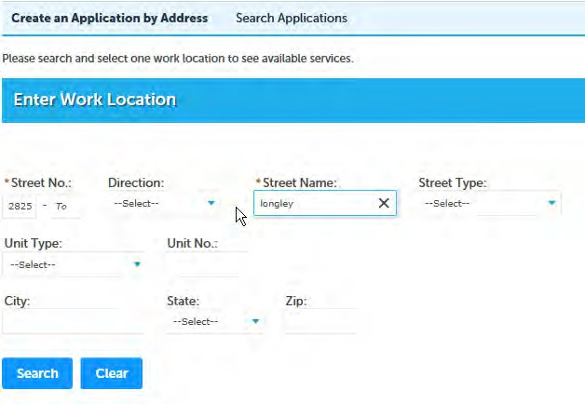
a. If more than one valid address is associated with your search location,
click “Select” under the Action column.
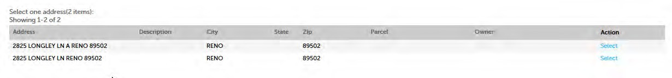
- A list of general permits and services available for address will be listed under Services below.

- Expand the general permit type by selecting the “caret” symbol to the left of the permit type. Select which specific permit you would like to apply for.
- Click on "Continue Application" and follow the step-by-step instructions on each following page to complete the permit application.
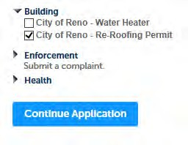

How do I submit a complaint?
To submit a complaint follow the links to the relevant agency from the
Enforcement tab.
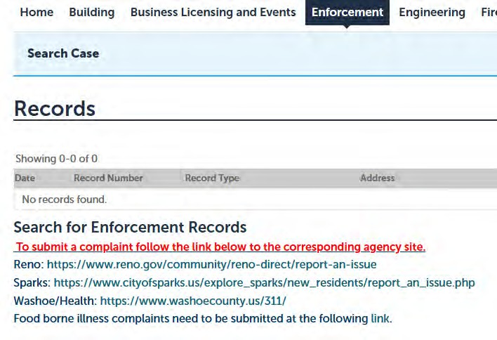

How do I apply for a Business License?
For a Business License or a Health Permit or to submit a code enforcement complaint:
Start by clicking on “Create An Application by Agency” and do the following:
- Under the Select Services header, expand the general permit type (Licenses for Business License, Health for Health permits and enforcement for Health and unincorporated County Code complaints).
- Select the specific license or permit you would like to apply for, or select the agency to file the complaint with. You can choose multiple licenses or permits and you will be guided through the application process for each license or permit type. You can also choose more than one agency for filing complaints.
- Click on “Continue Application” or “Continue Complaint” and follow the step- by-step instructions on each following page to complete the application or complaint. You may be required to enter a work location (see the above steps for other permits), contact lists, or your Nevada Business License ID.
