What do the symbols under the Status of my permit represent?

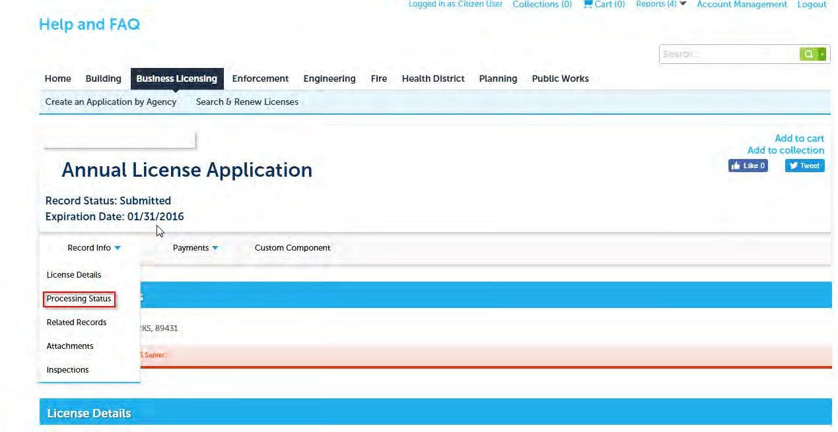
When you look under the “Processing Status” choice for Record Info of your license or permit, you might see several symbols. These symbols are associated with tasks associated with the workflow processing for the license or permit.

- The sideways black triangle indicates either that there are status updates to the task, and/or that there are “child” tasks (sub tasks) associated with a task. Click the black triangle to expand information about a task.

- A green checkmark means that the task is complete.

An hourglass means that the task is open and in process (has not been completed).

If there is no symbol next to a task name, it means that the task is not active.

